01. How to add a New Staff Member
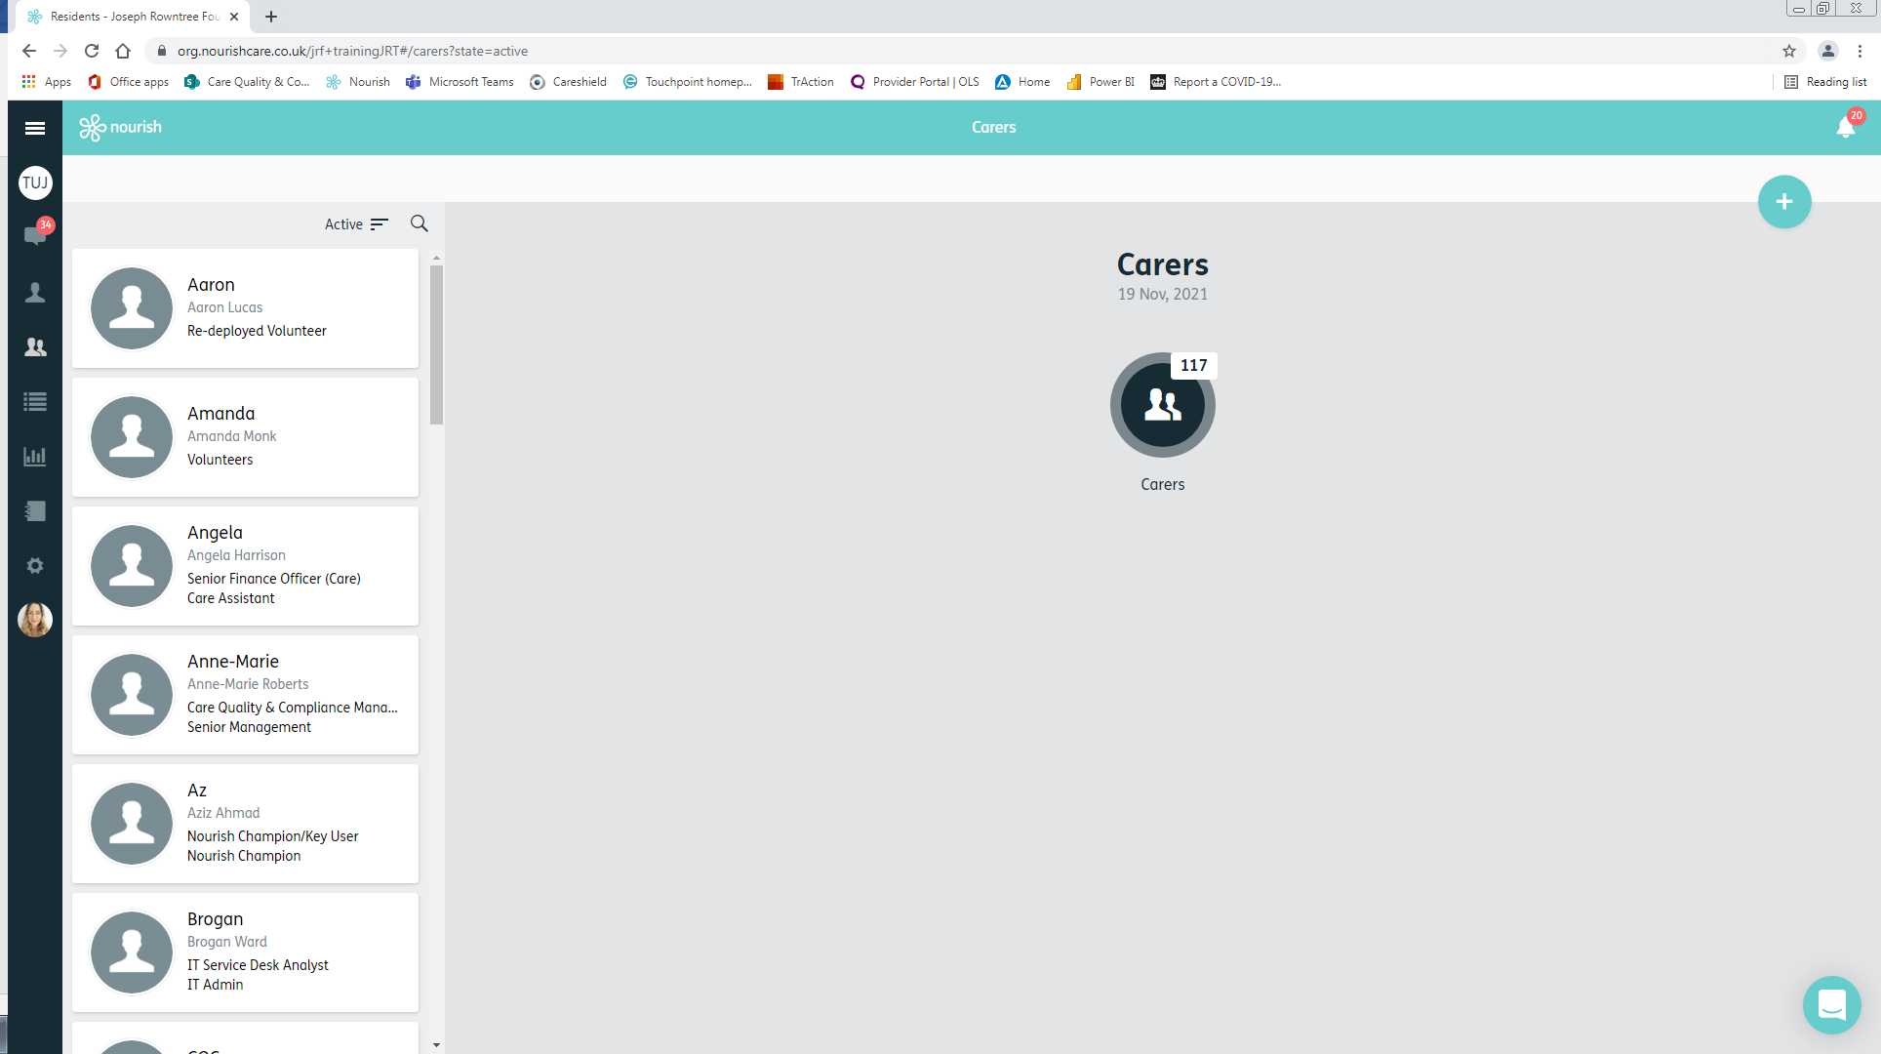

- Go to the list of colleagues by clicking on the following icon on the left-hand side of the screen.

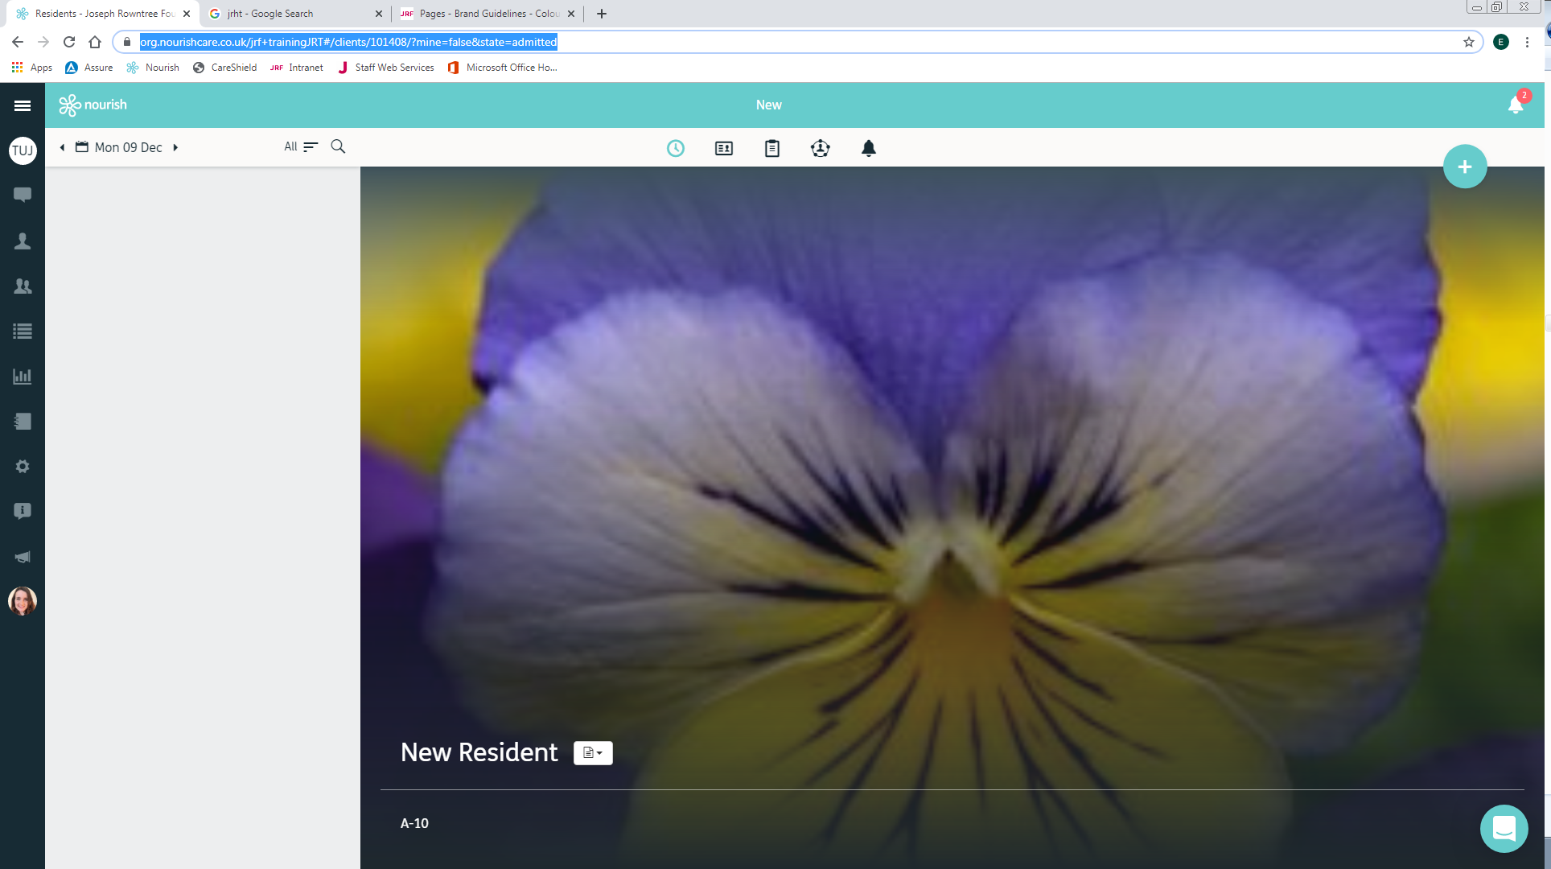
- Click on the + button to add a new staff member.

- Fill in all fields with an asterisk * (First name, Last name, Role, Gender, Date of Birth, Job Title)

Select the relevant role from the below list:
- Security Group Three – Home / Admin / Deputy Manager
- Security Group Four – Senior Care Assistants / Nurses
- Security Group Five – Care Assistants / Chaplains / Music Therapists / Activities Co-Ordinator
- Security Group Seven – One MHA Community Co-ordinator
- Security Group Eight – Communities Manager
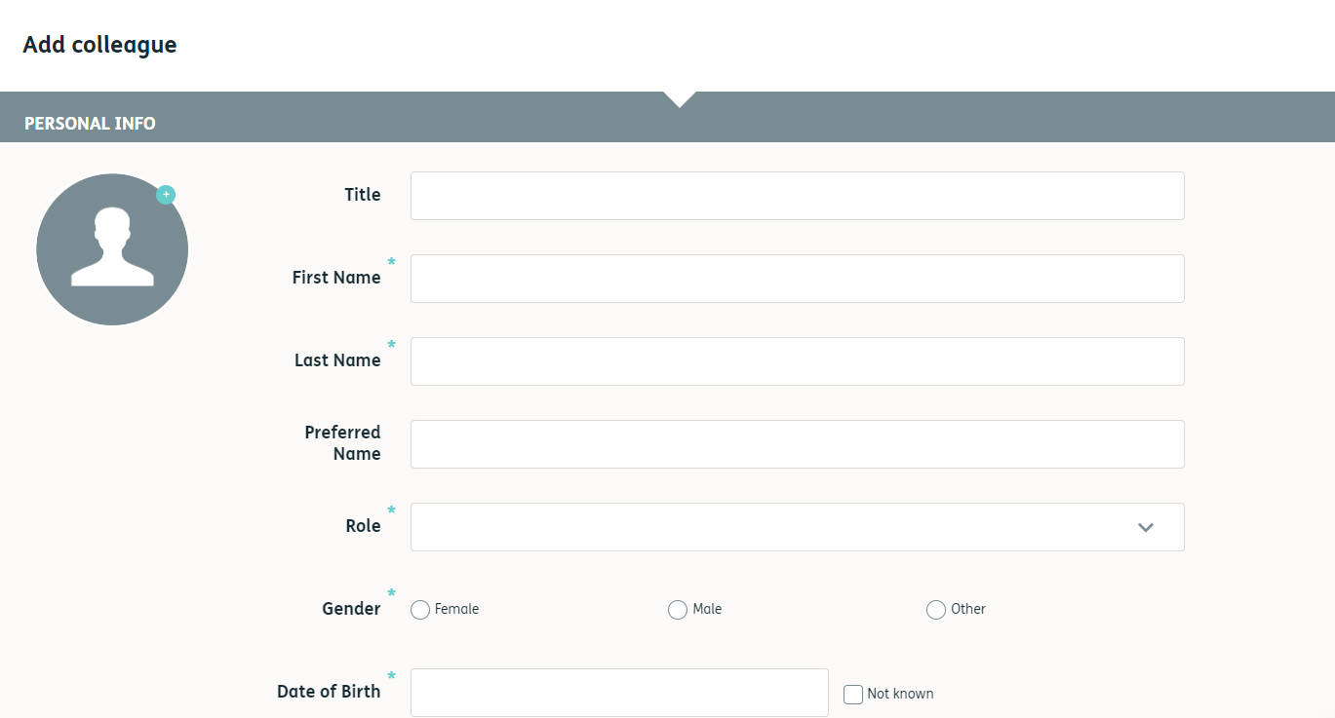

- Enter their email address in the Email field. This must be their MHA email address.
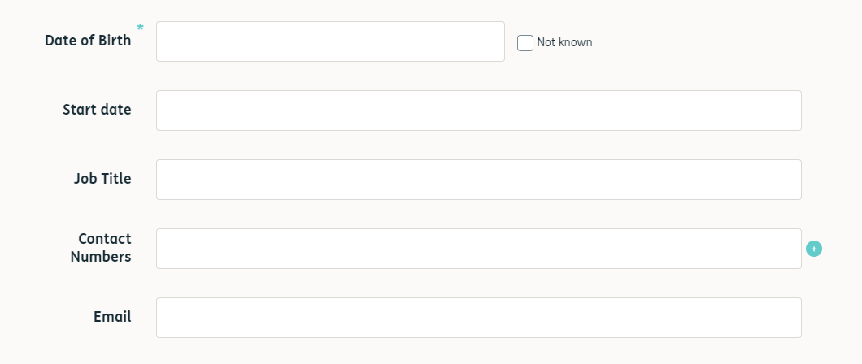

- Scroll down to the bottom, the username field must be left empty.

- Create a generic password to be changed by the person once they have logged on.
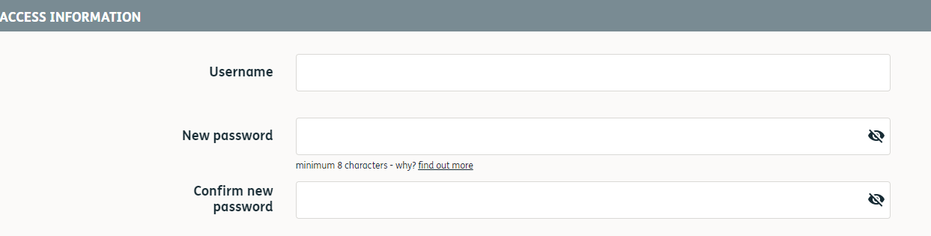

- Click save.
